Low Quantization Sensitivity/Minimum Delay IIR Filters

Overview

This paper is an outgrowth of an earlier paper whose focus was on very high-speed implementations of low-order Butterworth filters, in particular, high pass filters. A particular structure was employed that allowed low-order Butterworth filters (up to third order) to be implemented without multipliers if precise bandwidth control was not critical. Work on other applications, specifically for low-order lowpass filters for sensor filtering in automatic control systems identified some weaknesses in the structure previously employed with regard to minimizing phase lag impacts to servo control systems. Work to alleviate these impacts resulted in a slightly modified structure that well addressed this issue. But what also emerged was an understanding that this structure also has the attribute to minimize sensitivity to filter gain parameters and to digital word widths in comparison with structures like the Direct Form variations. These benefits arise for any order filter but the benefits increase with increasing order. These structures are applicable to both analog filter designs as well as digital filters through a simple mapping that produces excellent fidelity when mapping analog filters, e.g. Butterworth, Chebyshev. Bessel, Gaussian… to the digital domain. The study considers only all-pole filters but it is likely that similar results would accrue for filters with both poles and zeros.
The following two sections are almost identical to those from the earlier development. They are left pretty much as is for historical purposes. The sections that follow describe the issues with the original structures when employed for low-pass filtering with sensitivity to phase lag. One result form this extended study is the recognition that the original application could benefit from employing the new structures identified.

First-Order IIR Filter

An important component of this method is the realization of the HPF/LPF. These methods can be implemented without explicit multipliers, are amenable to high-speed operation, and can provide the very deep and narrow notches desired for the overall function. The filters are IIR and very simple implementations result for 1st and 2nd order structures. Both filters are based on transformations of analog filters using the “Mapping of Differentials” method [1].

Figure 1 illustrates the first-order structure.

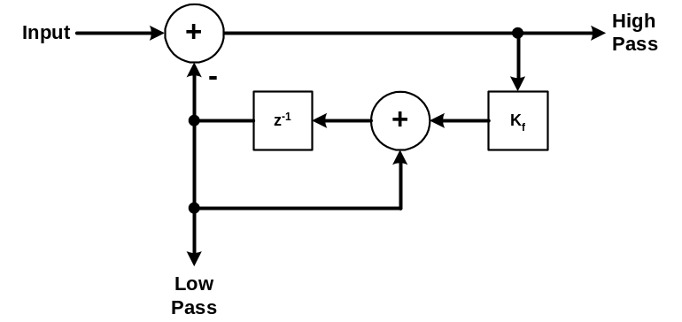

Figure 1. First-Order High/Low Pass Filter.

This structure is based on the analog filter shown in Figure 2. The low-pass output is a estimate of the input signal near dc that is subtracted from the input to yield the high-pass output.

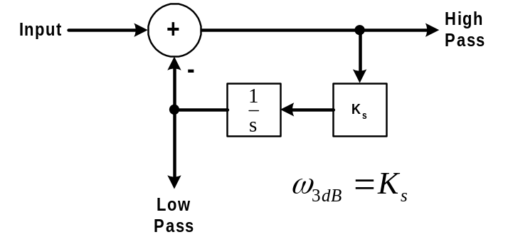

Figure 2. First-Order Analog Prototype.

The transfer functions to the low-pass, L(s), and high-pass output, H(s), are given by

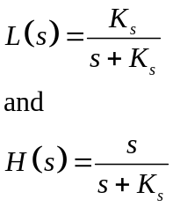

From the transfer function it is seen that the lowpass output is a unity gain estimate of the input signal near dc. This is subtracted from the input to yield the highpass output. From control theory, the existence of an integrator in the loop indicates there will be zero steady-state error at the highpass output of the input summer. This is evidenced by the s in the numerator of the highpass transfer function indicating a zero at dc. The bandwidth is K radians per second. The digital filter is obtained by substituting a digital integrator for the analog integrator. The corresponding digital transfer functions are given by

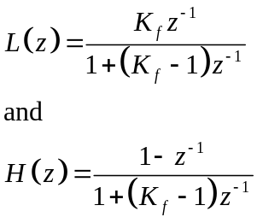

The transformation results in a zero at z = 1, the dual of dc in the z domain. The mapping of differentials analog to digital transformation indicates that K_{s} and K_{f} are related by

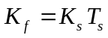

With this, the bandwidth of the filter is approximately given by

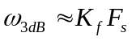

where F_{s} is the sample frequency.

Second Order Butterworth Multiplierless IIR

A second-order filter extending this basic topology is shown in Figure 3.

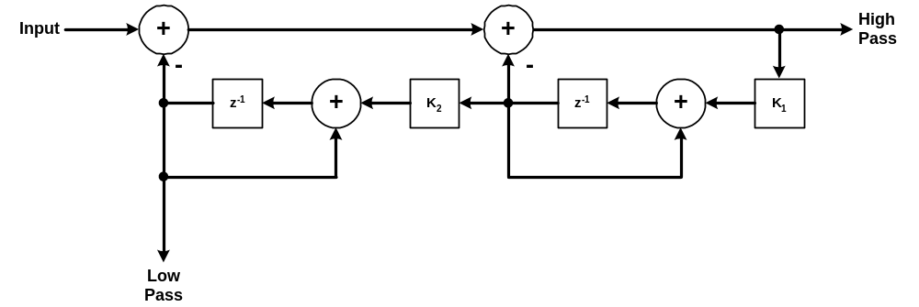
Figure 3. Second-Order Digital High/Lowpass Filter.

The analog prototype for this filter is illustrated in Figure 4.

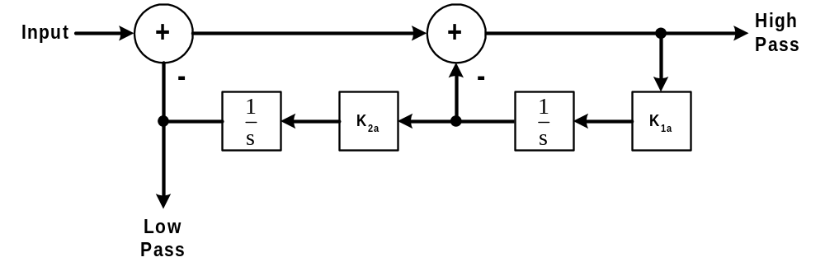

Figure 4. Analog Second-Order Prototype.

The transfer functions for the analog prototype filter are given by

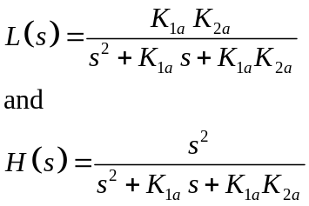

As desired, there is a double zero at dc in the highpass response. The Butterworth response provides a maximally flat response. The polynomial form for the Butterworth denominator is

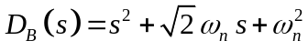

Fitting this response to the above transfer functions yields

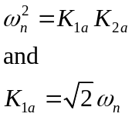

Squaring the second equation and substituting for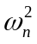 yields

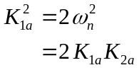

Simplifying yields

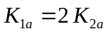

This factor of 2 ratio between the two factors is key to the simple realization of this filter.

Substituting this result for yields

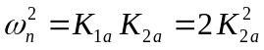

or

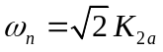

The analog-to-digital mapping provides the following conversions for the gain factor.

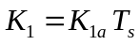

and

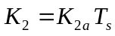

Let

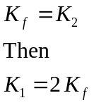

With these assignments, the approximate bandwidth of the digital filter is given by

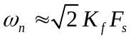
Then for design,

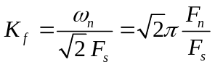

As was the case for the first-order filter, K_{f} controls the bandwidth. If K_{f} is chosen to be a power of 2, both scale factors can be implemented with simple shifts providing low complexity, high-speed implementations.

The transfer function for the digital filters is given by

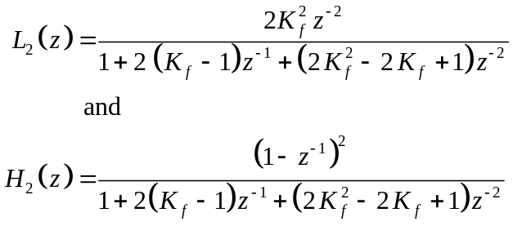

As desired, the highpass response has a double zero at z = 1 corresponding to the double zeros at dc in the analog filter.

Modification for Delay Sensitive Filter Applications

The material above was lifted from a paper where the primary application employed the highpass filter output and delay was of no importance. When lowpass filters are used in servo loop applications, it is imperative to minimize delay and the resulting phase lag that it produces. In the original application, high speed implementation in an FGPA was a critical concern. For that reason, the digital integrators employed had the delay elements in the forward path. This generally helps to maximize the time available for doing the required additions and subtractions from storage register, which z⁻¹ represents, to storage register. An alternate digital integrator places the storage storage register in the feedback loop. These variations and their transfer functions are shown in .

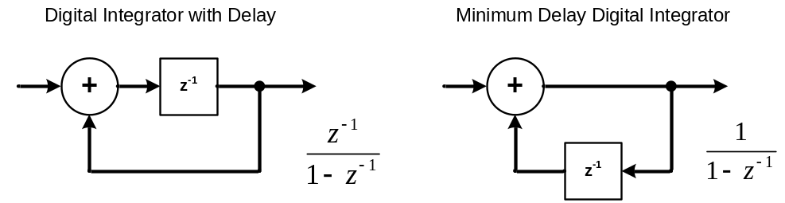

Figure 5. Digital Integrator Realizations

The transfer functions only differ in that the one used in the previous sections exhibits an addition unit delay as indicated by the z⁻¹ term in the numerator. The magnitude of these two frequency responses are identical with only the phase different due to the different delays.
For the material that follows, the structure of Figure 3 has been redrawn in to emphasize the lowpass output function.
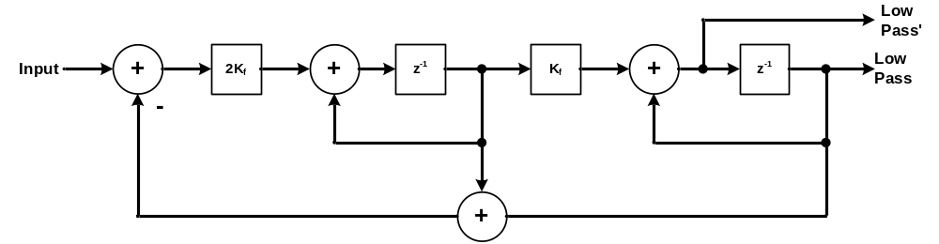

Figure 6. Structure of Figure 3 Redrawn to Emphasize Low Pass Output.

The transfer function for this is that given in the equation for L₂ above. Note that the numerator has a z⁻² term in it that implies a two-unit sample delay in the output. By using the Low Pass' output, one of these delays can be simply removed. For delay sensitive applications, removing both terms is desired.
The immediate thought is to employ the minimum delay integrator. If this is done, the resulting structure becomes that shown in

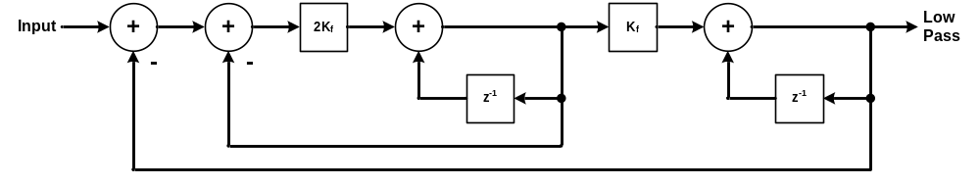

Figure 7. Filter Structure Employing Minimum Delay Integrators.

The feedback structure has been drawn to emphasize the presence of inner and outer loops. The transfer function for this filter is now derived in detail for completeness. The inner loop transfer function can be solved as
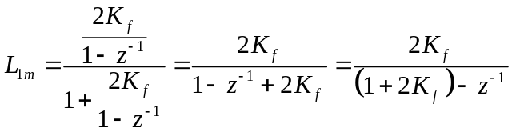

Here the subscript refers to a first-order section using minimal delay integrators. With this transfer function in hand, the overall transfer function can be solved for as
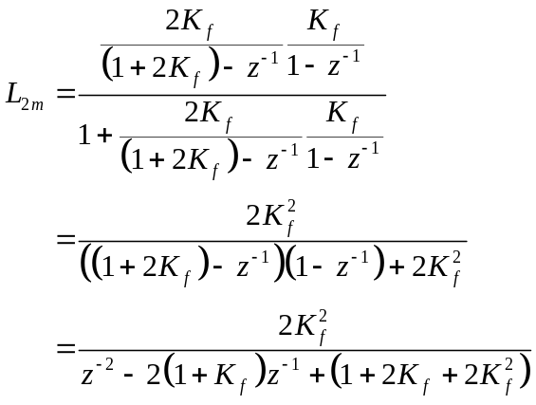

As desired, the numerator of this transfer function contains no z⁻¹ (delay) terms. For comparison with the early filter, that transfer function is restated in a form analogous to that for L_{2m},

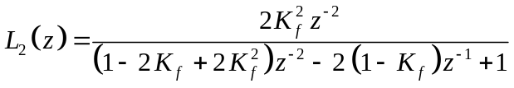

There are similarities but also differences in the denominator coefficients. These will be explored further shortly. Substituting z equals 1 into both transfer functions demonstrates both of these have unity gain at dc which was desired.

While we have eliminated the undesired unit delays, this transfer function is not realizable in hardware and software. Close examination of the inner and outer feedback loops reveals that there are what are termed algebraic loops present in both. This means there are looping paths where no unit delays are present. This is analogous to a dog chasing its tail and this cannot be realized. But all is not lost. An alternate structure can be formed that does not have these algebraic loops and still eliminates the unwanted delay terms. This structure is illustrated in Figure 8

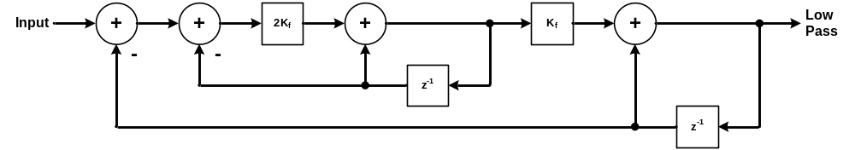

Figure 8. Minimal Delay Low Pass Structure without Algebraic Loops.

Here we have effectively used the integrator with delay realization for the feedback and the minimal delay integrator structure for the forward paths, i.e., we put the delays in the feedback eliminating the algebraic loops. The transfer function for the inner loop is given by

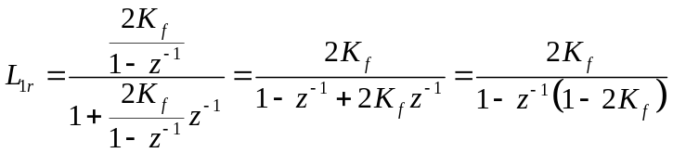

(Here the r in the subscript signifies realizable.) With this, the composite transfer function is given by
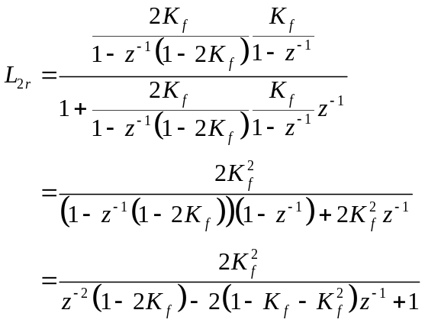

Again we see no undesirable delay terms in the numerator but again the coefficients terms in the denominator have shuffled around further. But a quick check again demonstrates the dc gain remains unity.
What has happened is that the use of the different digital integrator variations has resulted in different mappings. The mapping between the analog and digital frequency responses using the method of differentials is only an approximation. It is well known that this mapping is only applicable to low pass filters and that the mapping fidelity improves as the filter fractional bandwidth (relative to the sample rate) decreases. Our hope is that the differences in the pole locations in the denominator between these mappings are minor and decrease as the fractional bandwidth becomes smaller. In fact, we find this to provide a superior mapping as now further developed.
That the mappings are approximately equal can be illustrated in the pole mappings locations for the inner loops. Consider the transfer function for the inner loop in Figure 7,

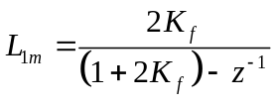

Solving for the z-domain pole location yield the pole is located at z equals 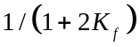. The transfer function for the inner loop of Figure 8 is given by

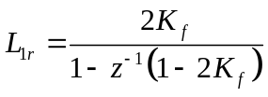
Its pole location is at 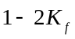. But using the first order Taylor series approximation,
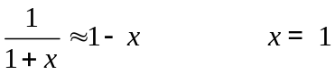
yields an approximate pole location for that structure also at . From the earlier equations, 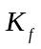 is proportional to the fractional bandwidth and, for small fractional bandwidths, well satisfies the condition that it be much much less than 1. The difference in these locations can be estimated using the two-term approximation,

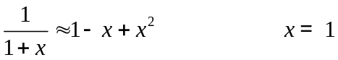

This shows the error here is on the order of 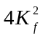, which, as expected, decreases as the fractional bandwidth decreases. Some work with comparison of pole locations between the three complete second-order structures using such approximations has shown similar results but the application of such approximations and the order of these approximations required to show the pole locations are close (for small fractional bandwidths) is somewhat ad hoc and is not developed here further.
To illustrate that the transfer functions and step responses are similar between these different structures an example is employed. For this example, a fractional bandwidth of 1/20th is employed. Fractional bandwidth here is defined as the ratio of 3 dB bandwidth to sample rate. It could be argued that a better definition for fractional bandwidth is relative to the Nyquist rate. (In that case the fractional bandwidth employed for this example would be 1/10. There is nothing jumping out to me at this time to indicate which definition is preferred.) The sample rate employed for this example is 1000 Hz with the desired filter bandwidth then 50 Hz. The frequency response for the analog Butterworth filter is included as a reference. The responses for three digital approximations are shown for comparison. One for the structure originally developed using digital integrators with delays, the second the unrealizable minimal delay filter using all minimal delay integrators, and the third where the forward path uses the minimal delay digital integrator but the feedback uses the delayed integrator outputs. These responses are shown in Figures 9, 10, and 11 with Figure 1Figure 9 showing the overall response, Figure 10 expanding the region near cutoff and Figure 11 expanding on the region below cutoff where a servo system loop crossover frequency would typically reside.
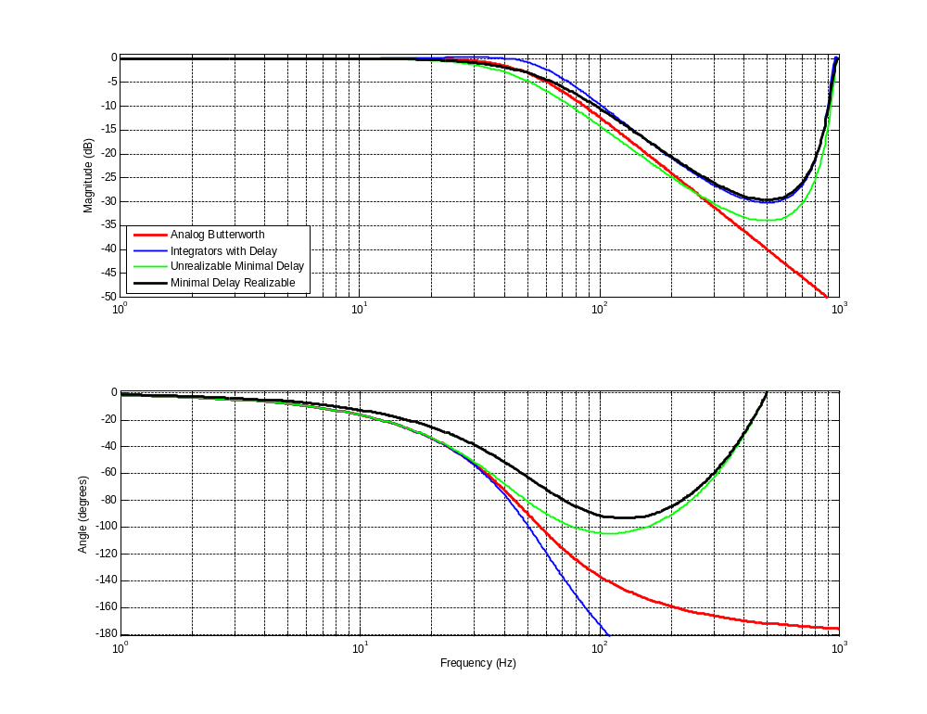
Figure 9. Second-order Butterworth Frequency Response; Overview

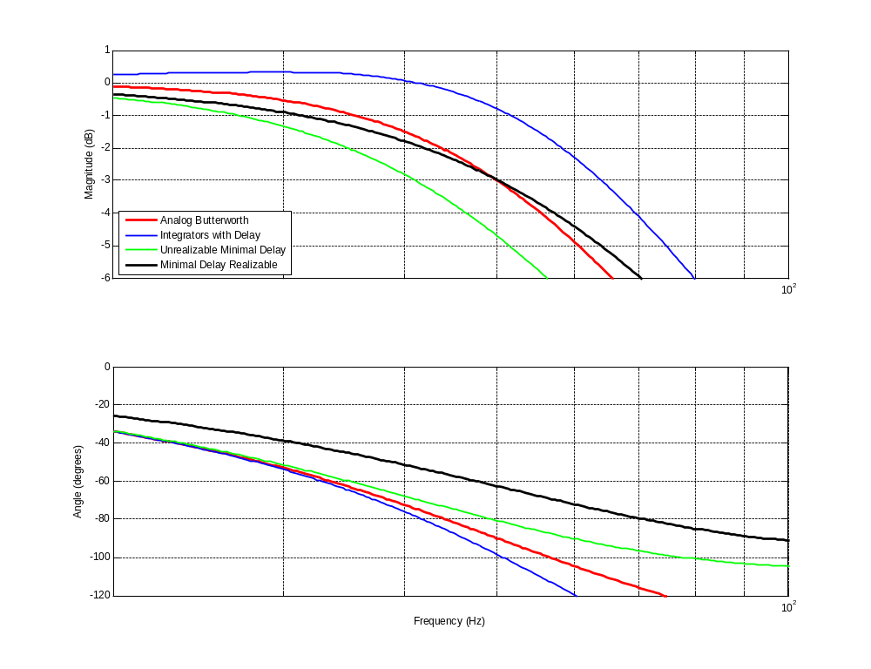
Figure 10. Expanded View Near Cutoff.

The initial discussion of these responses will focus on Figure 9 and Figure 10. Comment on Figure 11 follow. The red trace is the ideal analog Butterworth response. As noted, its 3 dB cutoff is at 20 Hz and the gain falls off at 40 dB/decade thereafter to infinity. The Butterworth response is maximally flat and monotonically decreasing with frequency. The phase response passes through -90 degrees at cutoff asymptotically heading for -180 degrees at infinity. All the digital filters magnitude responses must be periodic on the sampling rate which manifests here by the gain reaching a minimum and then returning to 0 dB at 1,000 Hz, the sampling frequency. The blue trace is based on the originally developed second-order approximations using digital integrators with delay. Immediately apparent is its magnitude response is above the ideal analog response and there is a noticeable increase in its 3 dB bandwidth. It also exhibits some slight peaking, about 0.31 dB, in its passband response. Its phase response falls off rapidly as the frequency increases due to the z⁻² terms in its numerator. The green trace is for the unrealizable transfer function using only the minimum delay integrator outputs. Its magnitude response is slightly below the analog response until well after cutoff before crossing the analog response as it starts to return to 0 dB at the sampling frequency. The black trace is for the new realizable minimum delay structure using both digital integrator outputs. Its response is slightly below the ideal response before the cutoff frequency and then crosses over it precisely at the crossover frequency before slowly rising above it as it begins its returns to 0 dB at 1,000 Hz. Its phase response is noticeably above all the other responses. Further comments on the implications of this response in servo applications are provided shortly.
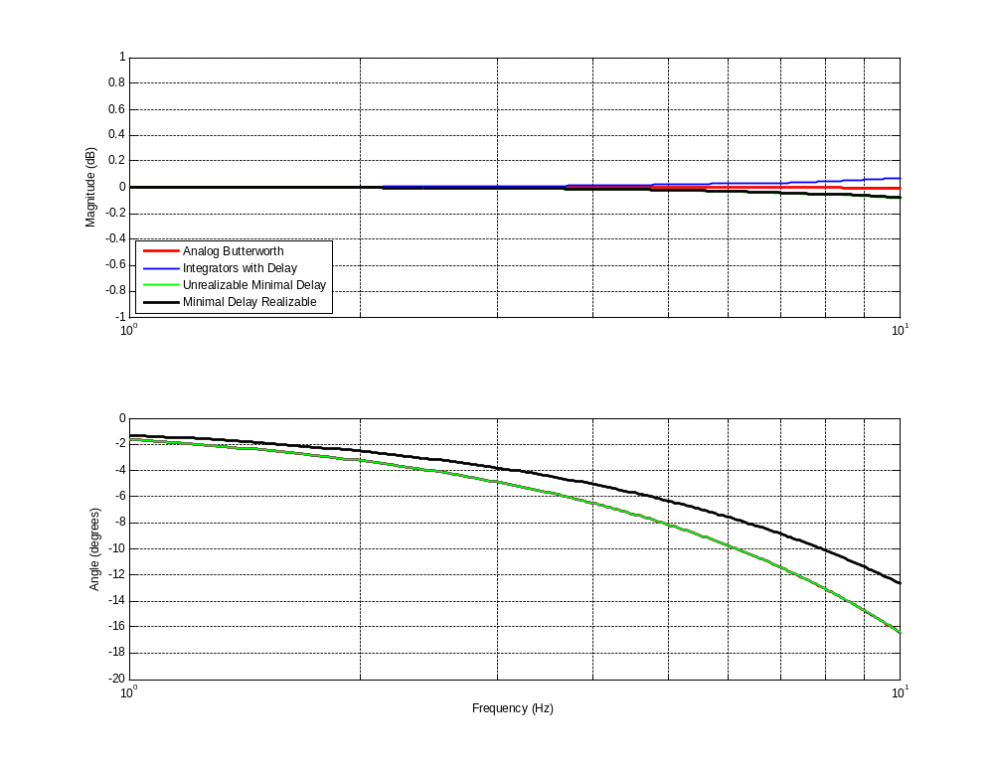
Figure 11. Expanded Below Cutoff.
The phase response portion illustrated in Figure 11 are particularly relevant to servo applications. Typically in servo system employing digital compensation and filtering the behavior in the region near the crossover frequency is of great import, particularly to stability and damping. The crossover frequency is usually at least a factor of 10 below where such a filter would be used to filter a sensor. ….

The pole locations for each of these filters are shown in Figure 12.
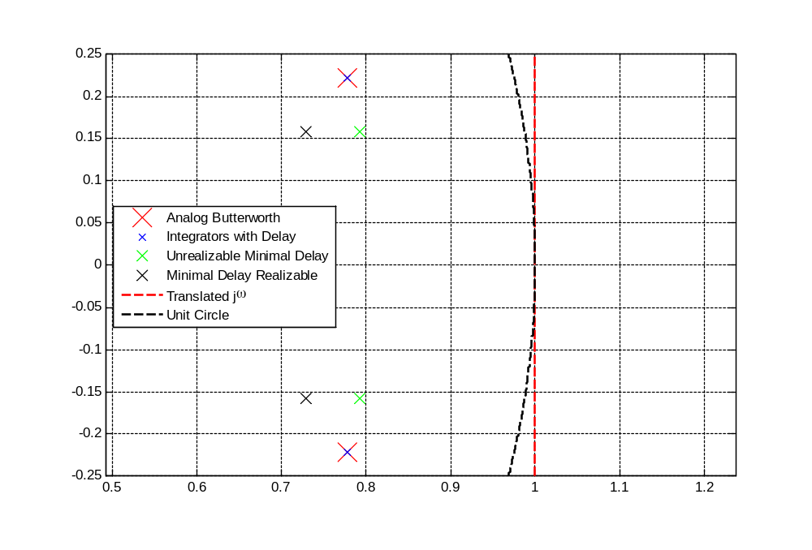
Figure 12. Filter Pole Locations.

The black dashed arc is the unit circle and the red dashed line represents the jω axis translated out by 1. The large red pole locations are that for the analog Butterworth response scaled for comparison with the digital poles. Note the angle of these poles is ±45° relative to the translated 0 frequency point in the s domain as is well known for the second-order Butterworth response. Very curiously, the mapping of the delayed integrator digital approximation’s poles falls directly on top of the translated analog poles. The reason for the peaking observed in its frequency response now becomes clear. For an analog frequency response, the magnitude response is found by moving along the jω axis in the s domain and drawing vectors to all its poles from each frequency of interest. The magnitude at a frequency is simply 1 over the product of the two vector lengths (for second-order filter). The response for the digital filter is similarly calculated but with the vectors drawn from the scaled frequency location on the unit circle (-1 corresponds to Fs/2). The vectors from the unit circle will clearly be shorter (for low fractional frequencies) than those from the translated jω axis for the analog response and the product will be smaller. Since these are in the denominator, the magnitude response will be greater and that results in the peaking observed. The double zero locations for this response are at the origin so their vector lengths are always unity and have no effect on the magnitude response. They only affect the phase response and are responsible for the strong linear phase component of this approximation at higher frequencies. The green pole locations are for the unrealizable digital approximation. Their real part magnitude being lower results in the reduced bandwidth observed for this approximation. The black poles are those for the realizable minimum delay approximation. That all these poles become more closely located as the fractional bandwidth decreases is demonstrated later in the sequel.

Figure 13 illustrates the step responses for each of these filters.
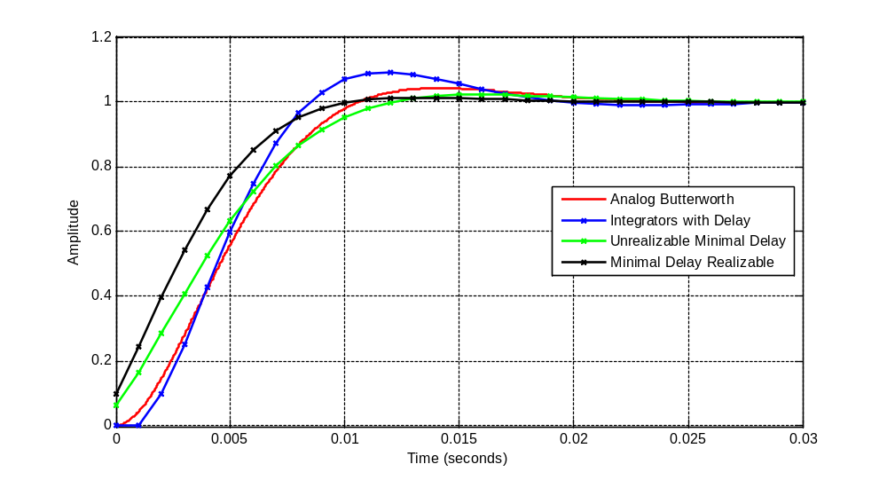
Figure 13. Step Responses.

The red response is again that for the analog filter. The x’s are those for digital approximations’ discrete outputs but connecting lines are included to better identify the general shape of these responses. The second-order Butterworth analog response is known to have a slight overshoot, about 4%, and that is evident. The blue response for the integrator with delay approximation is observed to have significantly greater overshoot. Upon reflection, one explanation for this is to think of the filter as a feedback system. It is well known that introducing delay into the open loop transfer function of a servo system generally reduces phase margin resulting in peaking in the frequency domain (observed earlier) and overshoot in the time domain. The effect of its two-unit delay terms in the numerator manifest in the response to the step being zero for the first two response samples. If this response is shifted back two samples, it is seen that it would have the fastest risetime (some of which is due to its overshoot). This can be understood by noting its frequency response was greater than all the other responses implying its bandwidth is higher than that for the other responses. If its design bandwidth was adjusted so that it would have the target 50 Hz 3 dB bandwidth, its response would be slower. The green response is for the unrealizable digital approximation. It was noted that its bandwidth was slightly lower and that manifests as a slower risetime. But its overshoot is much reduced and is lower that the true analog Butterworth response. Finally, the black response is for the realizable minimal delay response. It has several very desirable characteristics for servo system applications. First its risetime is faster than all the other responses (for the same 3 dB bandwidth) and its overshoot is the lowest in spite of the fact that it has the largest initial response to the step. This is a manifestation of the smaller phase lag evident in its frequency response at low frequencies.

The example fractional frequency was chosen so that the approximation effects would be obvious. As the fractional bandwidth is reduced, these approximation effects become much less noticeable. In the limit as the fractional bandwidth becomes very small, the differences become negligible. To illustrate this behavior, the frequency response, pole locations, and step response for a fractional bandwidth of 1%, 5 times smaller than the previous example, are shown in Figure 14, Figure 15, and Figure 16 respectively. Not only do the pole positions demonstrate convergence, the difference in the vector lengths between the unit circle and translated jω axis become smaller as the unit circle better approximates the jω axis for frequencies of interest.
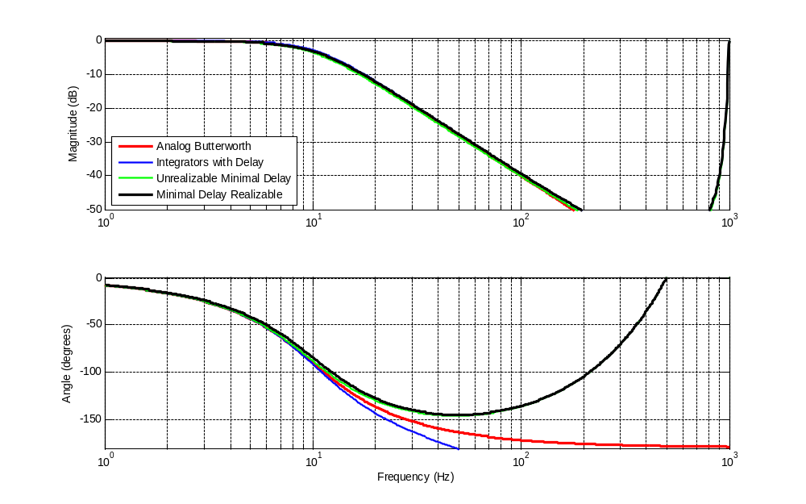
Figure 14. One Percent Fractional Bandwidth Transfer Functions.
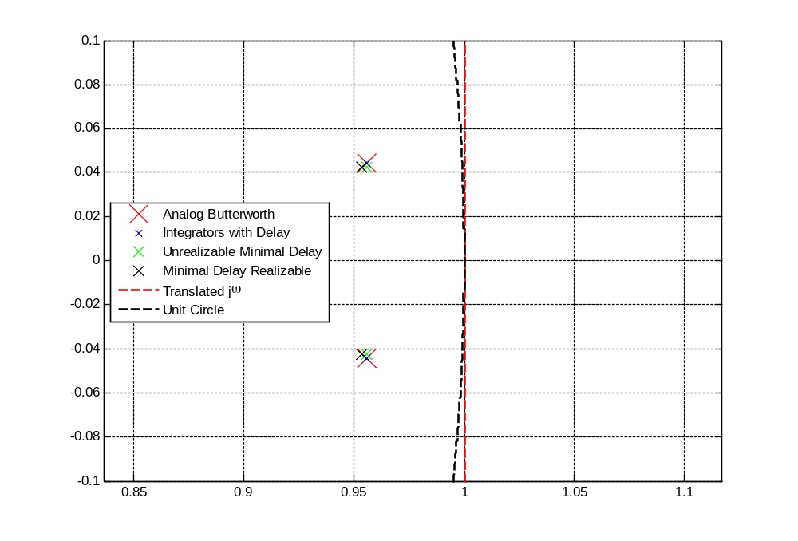
Figure 15. One Percent Fractional Bandwidth Pole Locations.
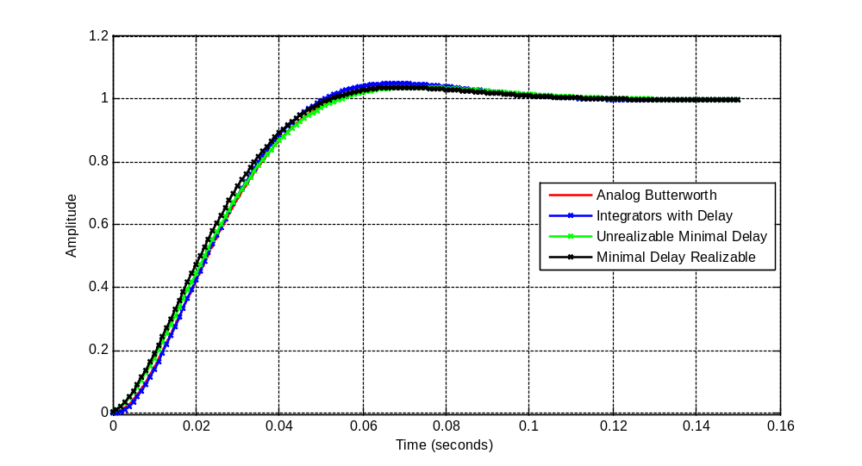
Figure 16. One Percent Fractional Bandwidth Step Responses.

Math Dynamic Range Reduction and Generalizations to Higher Orders

It seems inconceivable but the author is not aware of descriptions of the underlying structures employed in this development and the benefits that may be ascribed to their use. This goes to the implementation of arbitrary order analog or digital filters. The subject of coefficient dynamic range is developed for arbitrary order filters but, while somewhat muted for the low-order filters, is of general value when coefficient and data path widths are limited.
Consider first a generalized structure for implementing all-pole analog filters.

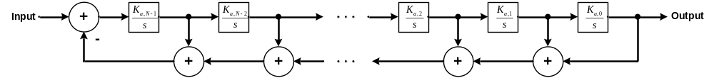

Figure 17. Generalized All-Pole Analog Filter Structure.

This is a slightly different numbering scheme for the gain factors from the previous developments but this scheme is slight better suited for the generalized structure. Through a simple left to right progression of block diagram inner loop reductions of this structure, it is easily shown that its transfer function is given by

Application of the final value theorem shows this structure always yields unity gain at dc, i.e., the numerator value is equal to the zero order coefficient of the denominator. Consider the first few order Butterworth polynomials for 1 radian/s cutoff filters.
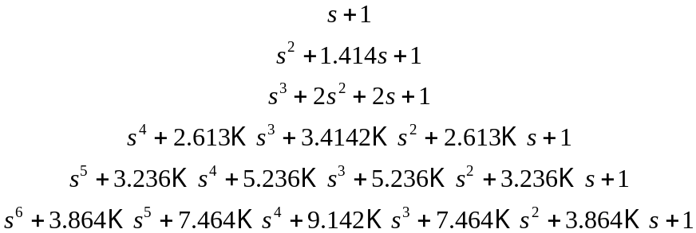

Aside from the symmetry (which does not generally manifest in other all-pole filters), it is seen that the polynomials are monic with the coefficient magnitudes growing slowly with order. The transfer function for these unity gain, unity radian bandwidth Butterworth filters are

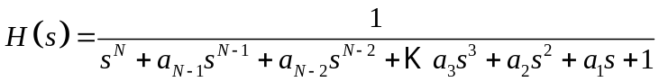
where the denominator polynomials are these Butterworth polynomials.

To realize an arbitrary bandwidth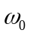, may be replaced by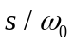yielding the transfer function

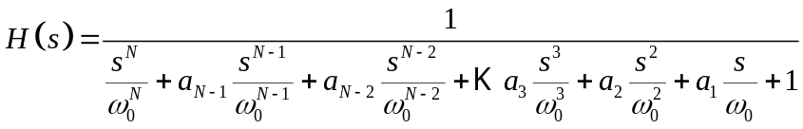

If the numerator and denominator are multiplied by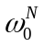, the denominator polynomial again becomes monic yielding

This is a form that can be directly compared to the transfer function for the generalized analog structure. Starting from the left, we see that the required integrator gains are given by

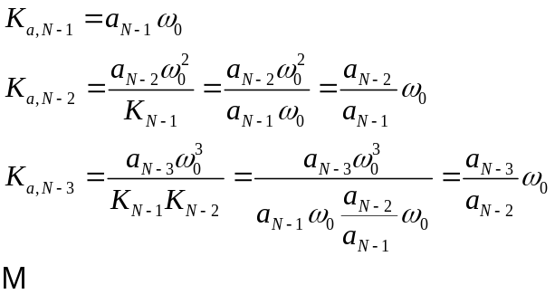

In general, the coefficients are given by

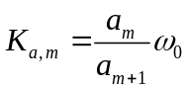

[As a check, for the second-order Butterworth filter K_{a,0} is 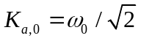and 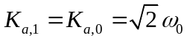. As was found before, these differ by precisely a factor of 2.]

What is seen is that all the gains are proportional to the filter bandwidth and the constant of proportionality is the ratio of the adjacent coefficients of the Butterworth polynomials. From the examples of these given above, it should be clear that these ratios are generally well behaved. For example, the coefficients for the fifth-order Butterworth filter, are given by

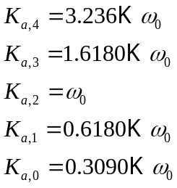

For the sixth-order filter, the coefficients are

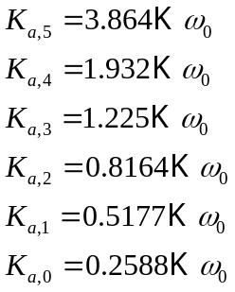

It is seen that the central coefficient is generally nearand the symmetry exhibited by the Butterworth polynomials is replace by a reciprocal symmetry. But the very desirable result is that the all the integrator gains are comparable when this structure is employed. This is not the case when the standard state feedback structure is employed where the gains are in the feedback paths.

The generalized digital structure corresponding to the above generalized analog structure is illustrated in .

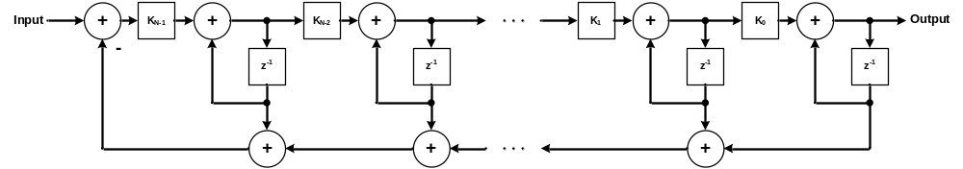

Figure 18. Generalized Preferred Digital Structure.

The mapping to the digital filter is simply the analog filter coefficients times the sample period 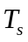, i.e.,

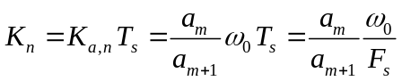

In general, the behavior that the digital structure coefficients’ gains are similarly well behaved and proportional to and on the order of the fractional filter bandwidth. As long as the filter order and the fractional bandwidth do not both get too high simultaneously, the coefficients will remain less that unity which again has implementation benefits. As noted, other common all-pole lowpass filters do not necessarily exhibit this coefficient symmetry but in general their generating polynominals are reasonably well behaved also. Given that, similar benefits would be expected to accrue to implementing filters, analog or digital, using these generalized structures.

Safe scaling of filters, in particular digital IIR filters, is always a concern. The behavior of the inner nodes of these analog and digital structures can be readily explored. The structure is just a cascade of integrators in the forward path so the response at the output of the 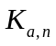 integrator is given by
where 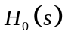is our normal lowpass output. As we move right to left, we get a succession of highpass unity gain (at infinity) filters. For the Butterworth denominator, the gain would never exceed unity at any frequency. For reasonably well behaved filter responses without excessive peaking, excursions above unity gain at any of these nodes would be limited and could be readily explored for any particular filter polynomial.
Areas for Further Investigation
This investigation has concerned itself with all-pole filter responses. The structures shown could be extended for general filters with poles and zeros by simply weighting and summing the successive integrator nodal outputs as illustrated in Figure 19

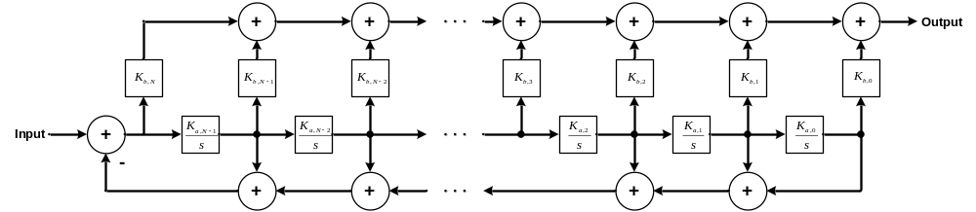

Figure 19. Generalized Pole-Zero Filter Structure.

It is hypothesized that this filter structure could yield similar benefits for the more general pole-zero transfer functions. A brief mention of a couple of special cases. If only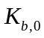of the feedforward coefficients is non-zero, it just sets the gain of the otherwise unity gain previously developed lowpass filters. If 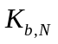is the only non-zero numerator coefficient, this yields a highpass filter with an N^{th} order zero at dc.

